**Candidate’s Name: ……………………………………………………………………**

**Signature: ……………………………….**

**545/1**

**CHEMISTRY**

**Paper 1**

**2024**

1 hour

**DAAR SSALAAM SECONDARY SCHHOL**

**SENIOR ONE END OF TERM TWO**

**CHEMISTRY DEPARTMENT EXAMINATIONS BOARD**

**Uganda Certificate of Education**

CHEMISTRY

**Paper 1**

1 hour

**INSTRUCTIONS TO CANDIDATES**

**ATTEMT ALL QUESTIONS**

|  |  |  |  |  |  |
| --- | --- | --- | --- | --- | --- |
|  | **For Examiner’s Use Only** | | | |  |
| **1** | **2** | **3** | **4** | **5** | **6** |
|  |  |  |  |  |  |

**SECTION A**

**ITEM 1**

The Uganda Civil Aviation Authority has hired an engineering company to reconstruct the recently damaged bombardier aircraft body. The chief engineer of the company wants to reconstruct a new, good and strong bombardier aircraft body.

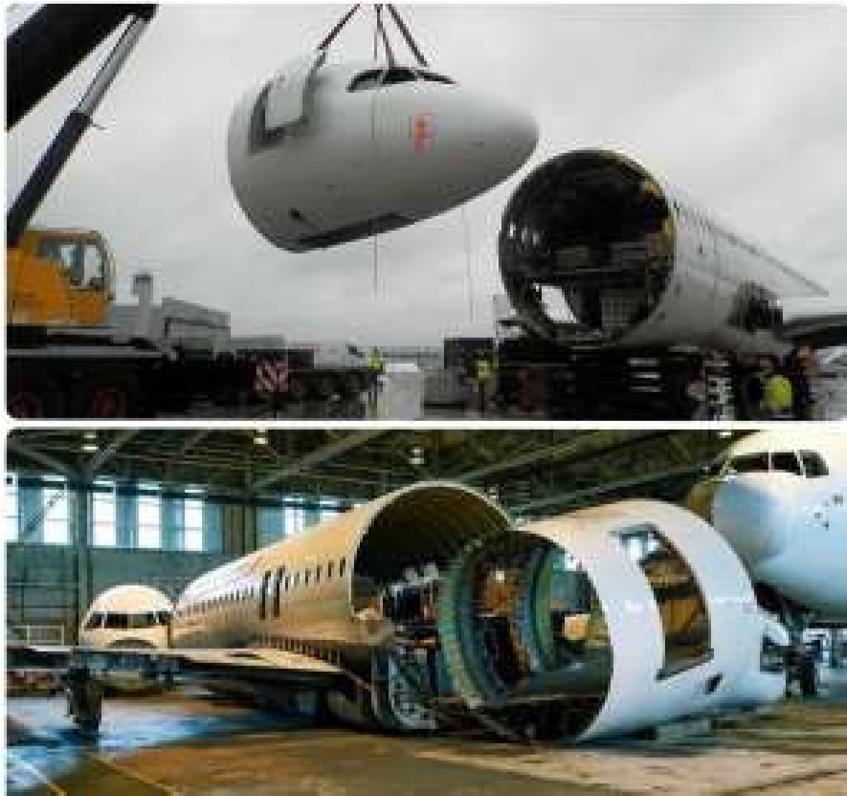

However the chief engineer knows that he has to choose the right material to be used with suitable qualities and properties and thus he has come to you for advice.

**Task:**

Use your chemistry knowledge to;

1. Explain
   1. The category of the material the engineering company will use

(*03 scores*)

_____________________________________________________________________

_____________________________________________________________________

_____________________________________________________________________

* 1. The suitability of the material (*04 scores*)

_____________________________________________________________________

_____________________________________________________________________

_____________________________________________________________________

_____________________________________________________________________

_____________________________________________________________________

_____________________________________________________________________

_____________________________________________________________________

1. The impact of the material to the environment. (*02 scores*)

_____________________________________________________________________

_____________________________________________________________________

_____________________________________________________________________

_____________________________________________________________________ _____________________________________________________________________

**SECTION B**

**ITEM 2**

Roko Construction Company has just completed a chemistry laboratory block in your community school. As a senior one student studying chemistry, advise the school administration on the common apparatus that they may need to purchase for the laboratory. Mention the uses of the apparatus and draw a diagram to illustrate each apparatus identified.

